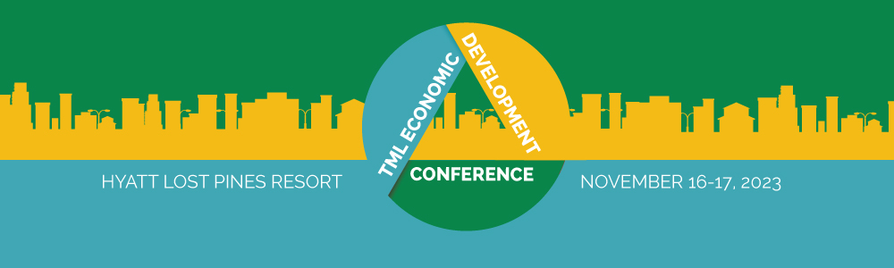

AGENDA

Thursday, November 16
8:00-8:40 a.m.
Registration and Light Breakfast
8:40-8:45 a.m.
Welcome
Bill Longley, General Counsel, Texas Municipal League
8:45-9:30 a.m.
2024 Texas Economic Forecast and What It Means for Cities
The Federal Reserve Bank of Dallas will share the Dallas Fed’s forecast for economic and employment growth and discuss the factors likely to influence Texas in 2024.
Luis Torres Ph.D., Senior Business Economist, Federal Reserve Bank of Dallas, San Antonio Branch

9:35-10:15 a.m.
Planning for Your City’s Economic Development
In this session, TML legal counsel will provide an overview of the basic legal requirements relating to the economic development tools that are available to Texas cities, and how those tools may be used to strengthen local economies.
Amber McKeon-Mueller, Assistant Director of Legal Services, Texas Municipal League
10:15-10:25 a.m.
Stretch Break
10:25-11:10 a.m.
Enforcement of Economic Development Agreements
In this session, our legal expert will review several economic development contracts, both successful and unsuccessful, as case studies. You will examine the enforcement provisions of those contracts to determine which type of enforcement mechanism provides the best protection for your city.
Thomas A. Gwosdz, Attorney, The Gwosdz Law Firm, PLLC
11:10 a.m.-Noon
Type A and Type B Economic Development Corporations and City Councils
A discussion of Type A and Type B economic development corporations, permissible expenditures and the relationship between City Council’s and the Corporations. This will include a discussion of permissible projects, process and procedures of EDCs, general authority EDCs, and the legal and practical relationship between EDCs and City Councils.
Dan Santee, Partner, Denton, Navarro, Rocha, Bernal & Zech, P.C.
Noon-1:05 p.m.
Networking Lunch (lunch is included in your registration fee)
1:10-2:00 p.m.
Will We Have Enough Water to Support Our Growing State and Cities?
A discussion with Brooke Paup, Chairwoman of the Texas Water Development Board, on state water planning to meet our state’s future needs and bills that passed in the 88th Texas Legislature related to water supply funding.
Brooke Paup, Chairwoman, Texas Water Development Board
2:05-3:15 p.m.
Strong Towns: A Bottom Up Revolution to Rebuild American Prosperity
In this presentation, Strong Towns Editor-in-Chief Daniel Herriges will explain how so many American cities have found themselves in decline after decades of “growth.” The problem lies in the current model of development — one which values short-term gains over long-term prosperity. To strengthen our cities and ensure their economic success, we must look to traditional ways of building cities. In this presentation, we show how active citizens, local officials and design professionals can change the negative trajectory in their towns and help them to become more resilient — no matter what challenges lie ahead. This core Strong Towns presentation is a game-changer for communities looking to grow more resilient in an uncertain future.
Charles Marohn, Founder and President, Strong Towns
3:15-3:30 p.m.
Stretch Break
3:30-4:00 p.m.
Economic Development: Legislative Outcomes and Outlooks
TML General Counsel Bill Longley will discuss the laws passed during the 88th Texas Legislative session that impact economic development in cities, and the issues that may be coming down the road.
Bill Longley, General Counsel, Texas Municipal League

Friday, November 17
7:30-8:00 a.m.
Light Breakfast
8:00-8:50 a.m.
Expanding Economic Prosperity in Texas Communities
Meet Adriana Cruz, Executive Director of Texas Economic Development & Tourism in the Office of the Governor, and learn how her office works with city and other local leaders to expand economic growth and job creation in rural, suburban, and metro communities across Texas.
Adriana Cruz, Executive Director, Texas Economic Development & Tourism
9:00-10:15 a.m.
Bricks and Clicks: Building a Successful Retail Strategy for Your Community
As the retail environment continues to evolve, municipalities must stay up to date on changing trends and opportunities in the industry. Join The Retail Coach as they discuss what steps municipalities can take to ensure their community capitalizes on retail opportunities in the coming years.
Aaron Farmer, President, The Retail Coach
10:15-10:30 a.m.
Stretch Break
10:30-11:45 a.m.
Texas Economic Development and Tourism
Scott Joslove, President and CEO of the Texas Hotel & Lodging Association and former chief of municipal affairs for the Texas Attorney General, is considered the statewide expert on the allowable uses of local hotel tax by cities. Scott will discuss how cities can legally use hotel tax and create Tourism Public Improvement Districts to promote tourism and strategically grow your local property tax, sales tax, and other city revenues.
Scott Joslove, President and CEO, Texas Hotel & Lodging Association

