Speaker Biographies
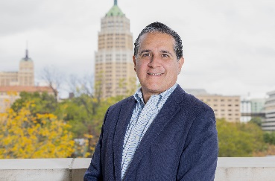
Luis Torres
Senior Business Economist, Federal Reserve Bank of Dallas, San Antonio Branch

Luis Torres joined the Federal Reserve Bank of Dallas in March 2022 as a senior business economist. Based out of the San Antonio Branch, Torres performs research and analysis on issues impacting Texas—specifically Central and South Texas—as well as Mexico and the border region. Torres received his bachelor’s degree in economics from the Monterrey Institute of Technology in Mexico. He received a master’s in economics from the University of Texas at El Paso, where his dissertation received honors. He later earned a scholarship to participate in the American Economic Association’s PhD Summer Minority Program. His PhD is from the University of Colorado at Boulder, where he specialized in international economics and econometrics. During his doctoral studies, he worked at the El Paso Branch of the Dallas Fed. From 1995 to 2012, he was with Banco de México in the research and institutional liaison departments. Prior to joining the Fed, he served as a research economist at the Texas Real Estate Research Center at Texas A&M University, studying regional economies, developing economic indicators and researching real estate markets.
Torres has taught classes and seminars at U.S. and Mexican universities as well as in national and international forums. He has published articles in academic and nonacademic publications about regional economies, international economics, real estate, trade and applied econometrics.

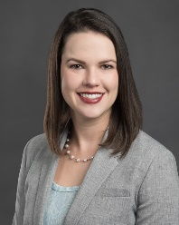
Amber McKeon-Mueller
Assistant Director of Legal Services, Texas Municipal League
Amber McKeon-Mueller is the Assistant Director of Legal Services for TML. Amber provides legal information to city officials, presents on issues relevant to cities, and monitors legislation during the legislative session. She graduated from the University of Texas School of Law and received her undergraduate degree from the University of Nebraska. Prior to joining the TML Legal Department in 2018, she worked for the Texas Attorney General’s Office as a litigator. She also litigated for over 6 years in private practice in San Diego, California.

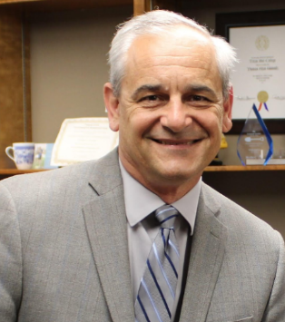
Thomas A. Gwosdz
Attorney, The Gwosdz Law Firm, PLLC

Thomas is a Fellow in the Society for Legal Scholars. He has taught attorneys, school trustees, and city council members at over two dozen local, regional and state-wide conferences, and he is the published author of several works, including his weekly newsletter The Executive Summary, and his upcoming book, Go Home Early: A Practical Guide to Streamlined Meetings.

He earned his Doctor of Jurisprudence from the University of Houston Law Center in 2001, and his Bachelor of Arts degree in English from Southwest Texas State University, in San Marcos, in 1994. He holds lifetime teaching certificates in Secondary English and Speech Communication from the Texas Education Agency.

Thomas was a staff attorney at the Texas Association of School Boards for five years, and the City Attorney of Victoria for thirteen. Outside of work, Thomas enjoys time with his family, including his wife, five kids and one grandbaby.

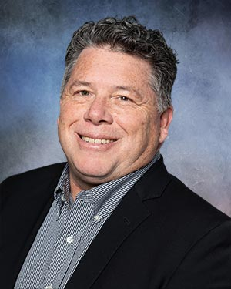
T. Daniel Santee, III
Partner, Denton, Navarro, Rocha, Bernal & Zech, P.C.

Dan Santee is a Partner/Shareholder in Denton Navarro Rocha Bernal & Zech, P.C., working out of the San Antonio office. He earned his Bachelor of Arts-Psychology from Baylor University in 1991, and his Juris Doctor from St. Mary’s University School of Law in December of 1994. Mr. Santee was admitted to the State Bar of Texas in 1995. He has 28 years of legal experience, 25 years of municipal legal experience, and 22 years of Economic Development legal experience. Mr. Santee is experienced in local government and municipal law, Texas Public Information Act, Open Meetings Act, ordinance, and resolution drafting, with expertise in land use, ordinance and code provisions, and economic development performance agreements. He is admitted to practice before the United States District Court for the Northern District of Texas. He holds merit certification for distinguished service in municipal law. He frequently trains city councils, economic development corporations and municipal development districts on the topic of economic development, and land use and ethics.

Brooke Paup
Chairwoman, Texas Water Development Board

Brooke Paup has served as a Board member of the Texas Water Development Board since February 22, 2018. Governor Greg Abbott designated her as Chairwoman on April 22, 2021.
Prior to her appointment to the Board, Paup served as the director of legislative affairs for the Texas Comptroller of Public Accounts for the previous three years. While there, she led a team of legislative professionals to address statutory tax reforms.
Paup is formerly the deputy division chief of intergovernmental relations and former special assistant for policy and research for the Office of the Attorney General, where she worked on legislative issues, special litigation, and public finance-notably House Bill 4 and Senate Joint Resolution 1 in the 83rd Legislative Session, which created the State Water Implementation Fund for Texas (SWIFT) and the State Water Implementation Revenue Fund for Texas (SWIRFT). Paup has more than 15 years of state government experience.
In September 2022, Governor Abbott appointed her to the Environmental Flows Advisory Group. She is also a member of the State Bar of Texas and Symphony League and a board member of the Wine and Food Foundation of Texas Auction Committee. Paup earned a Bachelor of Arts from Texas A&M University and a juris doctor from Texas Tech School of Law.
She lives in Austin with her husband, Spivey, and their two children, Henry and Heidi.

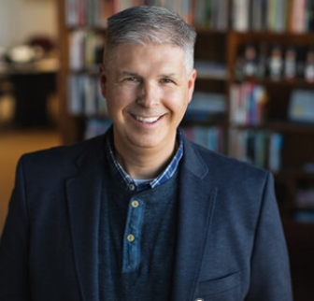
Charles Marohn
Founder and President, Strong Towns

Charles Marohn—known as “Chuck” to friends and colleagues—is the founder and president of Strong Towns. He is a land use planner and civil engineer with decades of experience. He holds a bachelor’s degree in civil engineering and a Master of Urban and Regional Planning, both from the University of Minnesota.
Marohn is the author of Strong Towns: A Bottom-Up Revolution to Rebuild American Prosperity (Wiley, 2019) and Confessions of a Recovering Engineer: Transportation for a Strong Town (Wiley 2021). He hosts the Strong Towns Podcast and is a primary writer for Strong Towns’ web content. He has presented Strong Towns concepts in hundreds of cities and towns across North America.

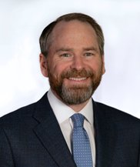
Bill Longley
General Counsel, Texas Municipal League
Bill Longley graduated from the University of Richmond in 2004 with a degree in political science and sociology. In 2007, he received his law degree from the University of Texas School of Law. Bill worked as a law clerk at TML while in law school. Prior to working for TML, Bill served as an Assistant Attorney General in the Open Records Division of the Office of Attorney General. In his 14 years at TML, Bill has worked on a variety of legal and legislative issues as they relate to Texas cities. He co-authored the TML Revenue Manual and TML Economic Development Handbook, and has spoken on numerous topics, with a focus on economic development, municipal revenue, open government, and elections.
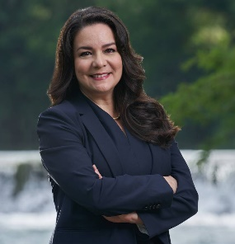
Adriana Cruz
Executive Director, Economic Development & Tourism Office of Governor Greg Abbot
In October 2019, Adriana Cruz was appointed to lead the Governor’s Economic Development and Tourism Office. The Office markets Texas as one of the world’s premier business and travel destinations. As Executive Director, Cruz provides leadership to Business and Community Development, Economic Development Finance, Texas Tourism, Texas Workforce Investment Council, Texas Music Office, and the Texas Film Commission.
Cruz has more than 20 years of leadership experience in economic development, marketing, and international business. Prior to her appointment to lead the Texas Economic Development and Tourism Office, Cruz was President of the Greater San Marcos Partnership, the regional economic development organization established to encourage and nurture economic growth in San Marcos, and Hays and Caldwell Counties. Previously, Cruz was the Vice President of Global Corporate Recruitment for the Austin Chamber of Commerce.
In April 2020, Cruz was appointed by Governor Greg Abbott to the Strike Force to Open Texas, a team of nationally recognized private and public leaders to advise the Governor on safely and strategically reopening the state of Texas. In January 2020, Governor Greg Abbott appointed Cruz to the Advisory Council on Cultural Affairs, and named her vice chair of the council. In 2021, the Governor appointed Cruz to the Texas Freight Advisory Committee and the Broadband Office Board of Advisors. She also serves on the Texas Economic Development Council and the Texas Workforce Investment Council. In addition, from 2016 to 2019, she served on the Texas Economic Incentives Oversight Board, to review the efficiency of Texas’ incentive programs.
In 2016, she won the Austin Business Journal’s Profiles in Power: Central Texas Women of Influence Award. Cruz holds a B.B.A. in Marketing from the University of Texas at Austin, has been married for 34 years to her husband Rik, and has three grown children living in the Austin area.
Aaron Farmer
President, The Retail Coach

Aaron Farmer brings to The Retail Coach knowledge of the most current research on retail and marketing trends. Prior to joining The Retail Coach, Aaron was employed in marketing research and retail development where he worked on projects for some of America’s leading retailers and restaurants including FedEx-Kinkos, Sally Beauty Supply, Adidas, Concentra, and the National American Association of Subway Franchises. Aaron holds a degree in Marketing from The Mays Business School at Texas A&M University and an MBA from Texas A&M University – Commerce. Aaron and his teamwork with municipal leaders across the State of Texas to recruit new retail development to their communities.

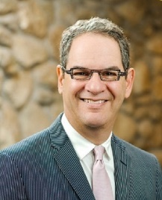
Scott Joslove
President and CEO, Texas Hotel & Lodging Association
Scott Joslove has served as President and CEO of the Texas Hotel & Lodging Association (THLA) for the past 23 years. In that time, THLA has grown from the fourth largest state hotel association to the largest state hotel association in the nation, with over 5,000 lodging-related member businesses, from the smallest bed and breakfast properties to the largest convention center hotels.
Since joining THLA, Scott and his staff have passed every legislative bill they have offered over the last twenty years and have defeated every legislative initiative opposed by the lodging industry. The International Society of Hotel Associations has recognized THLA ten times for having the Best Membership Program and the Best Governmental Affairs Program in the nation. Scott was recognized with the Top Watchdog award by the San Antonio Tourism Council, the Anthony G. Marshall Hospitality Law Lifetime Achievement Award, the Lifetime Achievement award from the Hotel & Lodging Association of Greater Houston, and the first non-elected official to receive the Friend of the Hotelier Award from the Asian American Hotel Owners Association.
Scott has a master’s degree in public administration and has been a licensed attorney for over 25 years. Prior to joining THLA, Scott served as Chief of Municipal Affairs for the Texas Attorney General and as First Assistant General Counsel for the Texas Municipal League.

